ARTNET NEWS Art World

‘This Donation Gives Meaning to Our Life:’ Collectors Claude and France Lemand Donate 1,300 Works to Paris’s Institut du Monde Arabe
The donation from the Lebanese-born dealer and collector also sets up an endowment for the museum.
Sarah Cascone, October 29, 2018
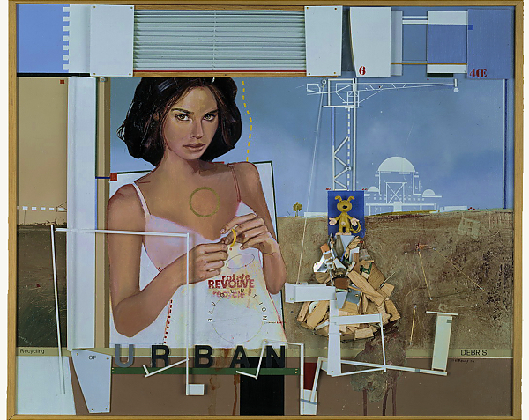

Mohammed Al-Rawas, Urban Debris (2004). Courtesy of the Institut du Monde Arabe, donated by Claude and France Lemand.
The Paris-based art dealer and collector Claude Lemand and his wife, France, donated some 1,300 works of art to the Institut du Monde Arabe. It’s one of the largest donations in the Paris museum’s history and includes funds for an endowment that will support the future exhibitions, acquisitions, research, and catalogue publication.
Lemand left his native Lebanon in the mid-1970s, when civil war broke out. When he founded his gallery in Paris in 1988 he dedicated it to Arab artists who, like him, had settled in the West. He and his wife also amassed an impressive collection of Arab art themselves. The acquisition of the Lemands’ collection will increase its holdings of Modern and contemporary art by two thirds.
“I remain personally very attached to the Arab world,” Lemand said in a statement. “The goal of my gallery is to make better known the art of the Arab world to the West.” Leaving his personal collection to a museum in his adopted hometown of Pairs was a natural extension of that mission.
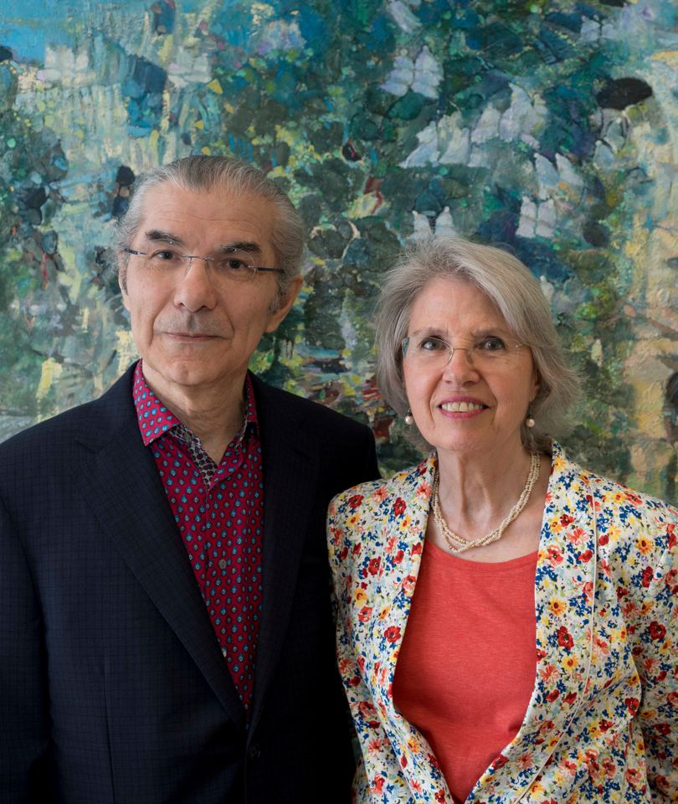
Claude and France Lemand. Photo courtesy of the Institut du Monde Arabe.
“I wanted to show how much an émigré of Arab culture and a French universalist is capable of initiative and generosity,” Lemand added. “This donation gives meaning to our life and, when we are gone, the works of art will continue to testify to our passion to future generations called to visit this museum.”
The works include oil paintings as well as watercolors and gouaches, drawings, sculptures, prints, artists’ books, photographs and ceramics, dating from the present day back to the 19th century. The 94 artists in the collection include Algeria’s Zoulikha Bouabdellah, Syria’s Youssef Abdelké, and Lebanon’s Shafic Abboud.
As reported by the Art Newspaper, the museum has already mounted three exhibitions featuring some of the donated works, which are on view through March 10, 2019. It plans to show the remaining works in a rotating display.

See some of the donated works below.

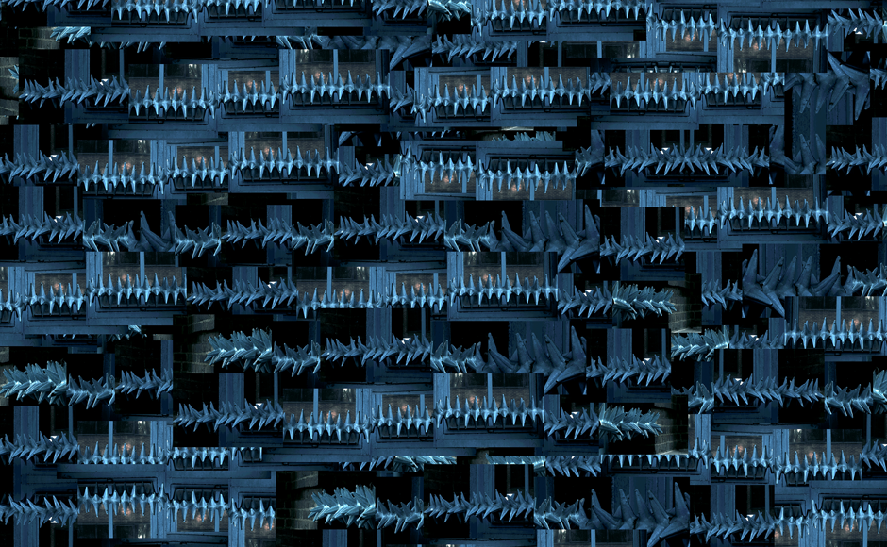
Steve Sabella, In exile 1 (detail) (2008).
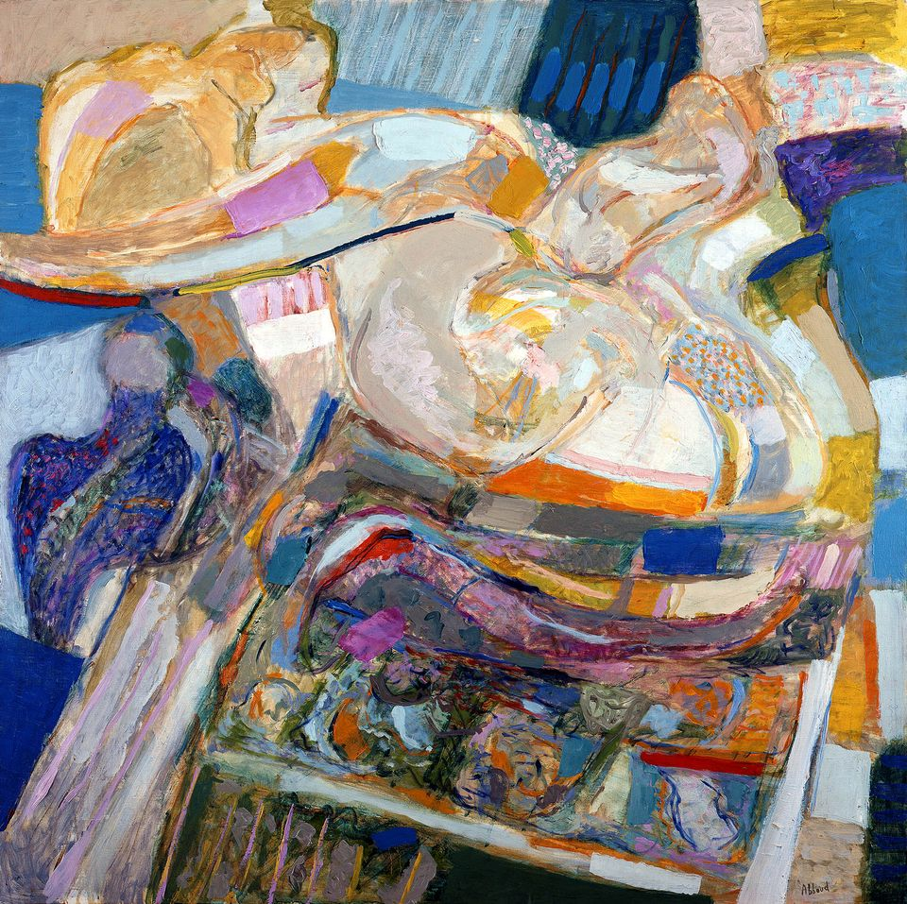
Shafic Abboud, Confidences (1981). Courtesy of the Institut du Monde Arabe, donated by Claude and France Lemand.
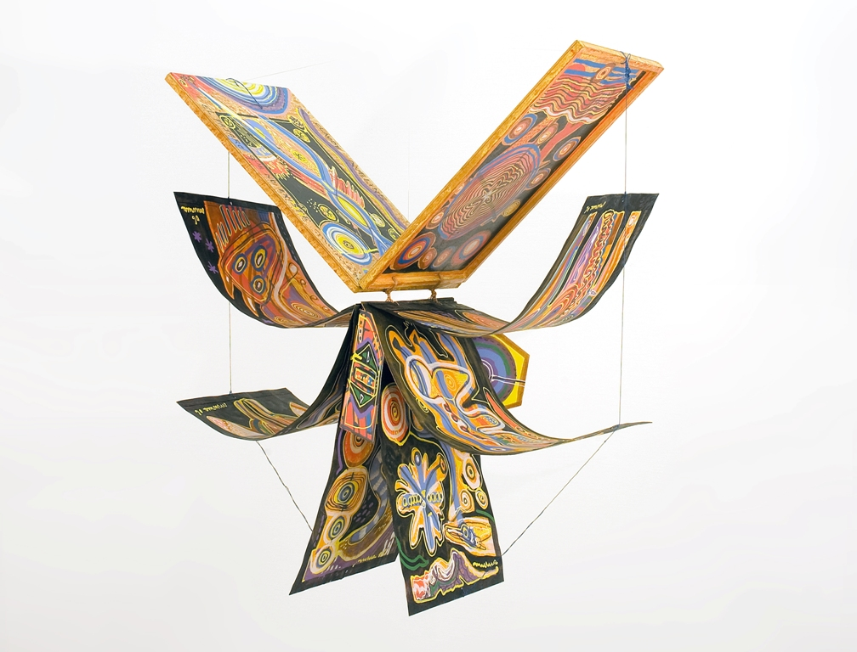
Mario Murua, livre unique peint, à suspendre pour le déployer en oiseau (2005). Courtesy of the Institut du Monde Arabe, donated by Claude and France Lemand.
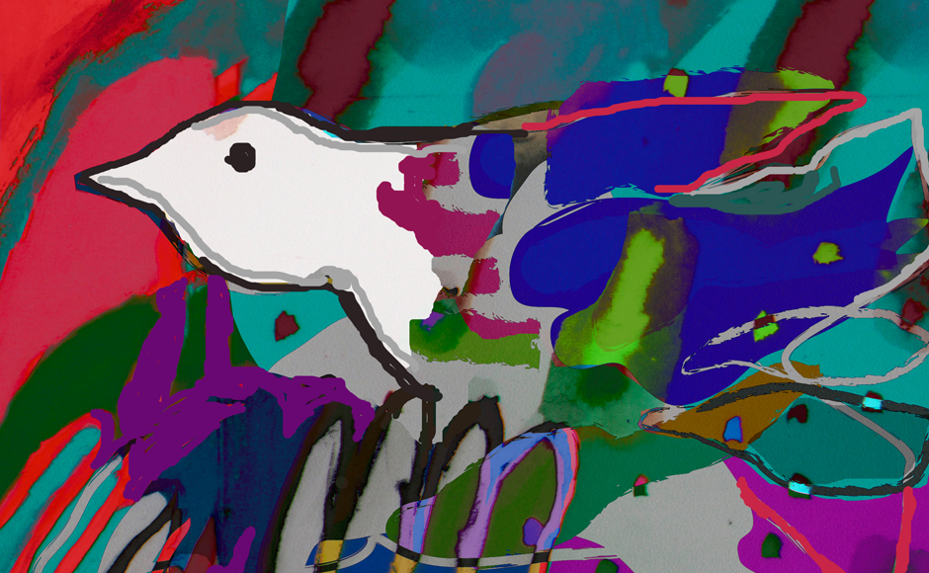
Dia Al-Azzawi, Portrait de l’Oiseau-Qui-N’Existe-Pas (2004). Courtesy of the Institut du Monde Arabe, donated by Claude and France Lemand.
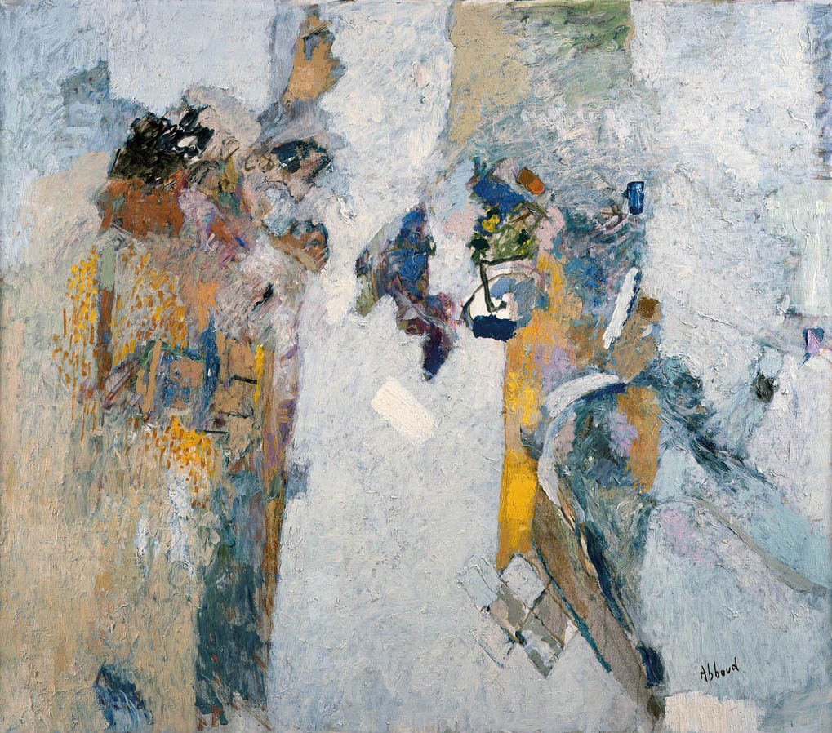
Shafic Abboud, L’Aube (2003). Courtesy of the Institut du Monde Arabe, donated by Claude and France Lemand.
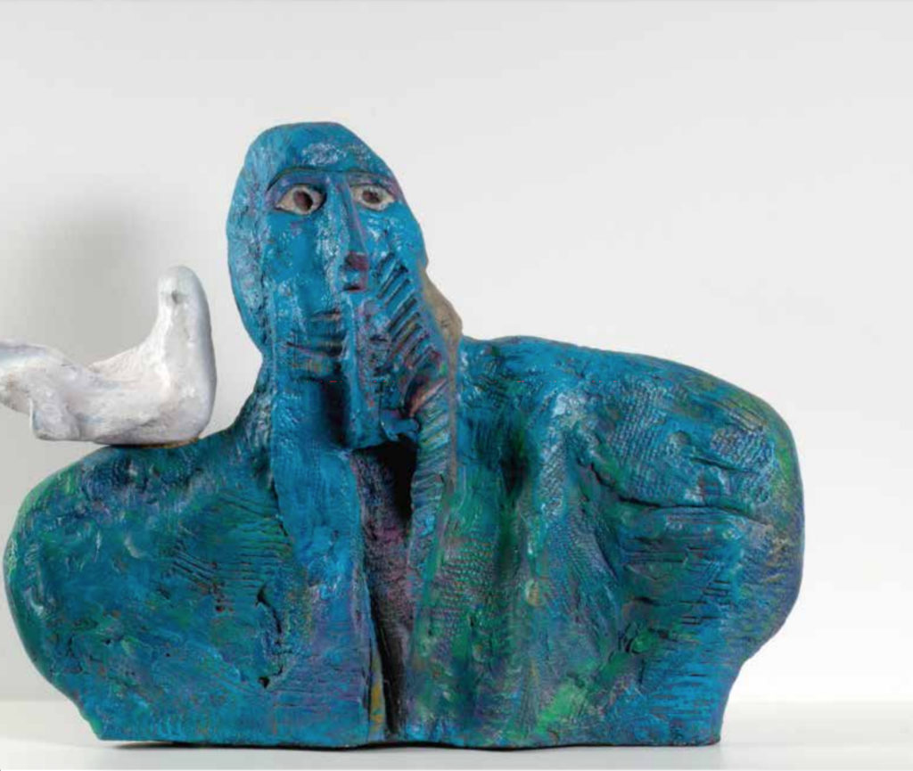
Dia Al-Azzawi, Peace Lover (1986). Courtesy of the Institut du Monde Arabe, donated by Claude and France Lemand.

https://news.artnet.com/art-world/claude-lemand-donates-1300-works-paris-institut-du-monde-arabe-1382134

Major coup for Paris’s Institut du Monde Arabe as it receives one of its biggest ever donations of works

Gallerist Claude Lemand and his wife France also set up a fund to support the museum.

THE ART NEWSPAPER , Gareth Harris, 29th October 2018. 11:59 GMT
The Institut du Monde Arabe (IMA) in Paris has received one of its largest donations ever from the dealer and collector Claude Lemand and his wife France who have given almost 1,300 works to the institution by artists of Arab origin. The couple have also initiated a permanent fund in addition to the donation—called the Claude & France Lemand-IMA Fund—which will be used to secure “acquisitions, organise exhibitions, research works and publish catalogues”, says an IMA statement.
Works donated include LOVE Bleu Blanc Rouge (2014) by Zoulikha Bouabdellah, who is of Algerian descent, and L’Aube (2003) by the late Lebanese painter Shafic Abboud. A selection of works from the collection are on show at the IMA (until 10 March 2019), with the remainder to eventually go on rotating display.
The donation includes 23 works by the Syrian artist Youssef Abdelké, dating from 1991 to 2017, which “present a dramatic and gripping picture of Syria’s martyrdom”, the couple say; these include Nude (2015) and Figures (1993).
“It was in Egypt that we made our first acquisitions: we bought from Aïda Ayoub [gallery] in Cairo an ink drawing by Abdel Hadi El-Gazzar and a large masterpiece by the same artist, Abou Ahmed The Mighty of 1951, which is now in a private collection in Doha; we paid a total of around the equivalent of 30,000 French francs at the time,” Lemand told AB magazine.
Lemand runs two galleries in Paris, setting up the business in 1988, and was one of the “first [Western] gallerists to embark on promoting major Arab artists who had settled in the West”, according to the gallery website. “It was challenging to start from scratch, to build relationships with the media and with publishers, to establish a solid client database and to gain the Parisian art scene's trust. My clientele was mainly French at the beginning and then European,” says Lebanon-born Lemand, a former professor of linguistics.
Securing the donation is another coup for Jack Lang, the former French culture minister and president of the IMA. In March, the first works donated to the IMA for the collection of the planned Palestinian museum of modern and contemporary art were unveiled.
“The IMA is a museum of France, signifying that anything that comes into the museum can never be deaccessioned, unlike US museums,” Lemand says. “Jack Lang has the same vision as us: we did not expect a dime from this donation but we had the guarantee that no work from our collection could ever leave the IMA museum. This comprehensive ensemble of more than 1,200 works will fuel the dynamism the IMA has been seeking for its museum over the last few years—it needs this ‘art boost’ for the years to come.”
Légendes des 2 illustrations :
Shafic Abboud's Confidences (1981) is one of the donated works. Courtesy of the Institut du Monde Arabe.
Claude and France Lemand. Photo: Dahmane, June 2018

https://www.theartnewspaper.com/news/lemand-donation-ima

